# Why should we choose Artsmark?

**Photo © The LPA/ Hillyfield Primary Academy**

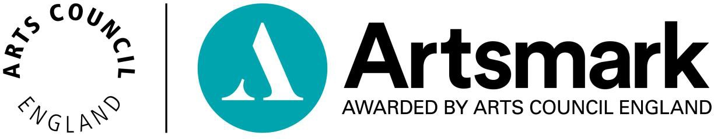

# What is Artsmark?

* Artsmark empowers teachers with the skills they need to embed arts, culture and creativity across the whole curriculum.
* Schools are recognised for their exceptional commitment to creativity with the [**Artsmark Award**](https://www.artsmark.org.uk/about/awarding), accredited by Arts Council England – the only award for arts and cultural provision in England.



# Why Artsmark?

* Over 20 years’ experience transforming schools through arts and culture
* 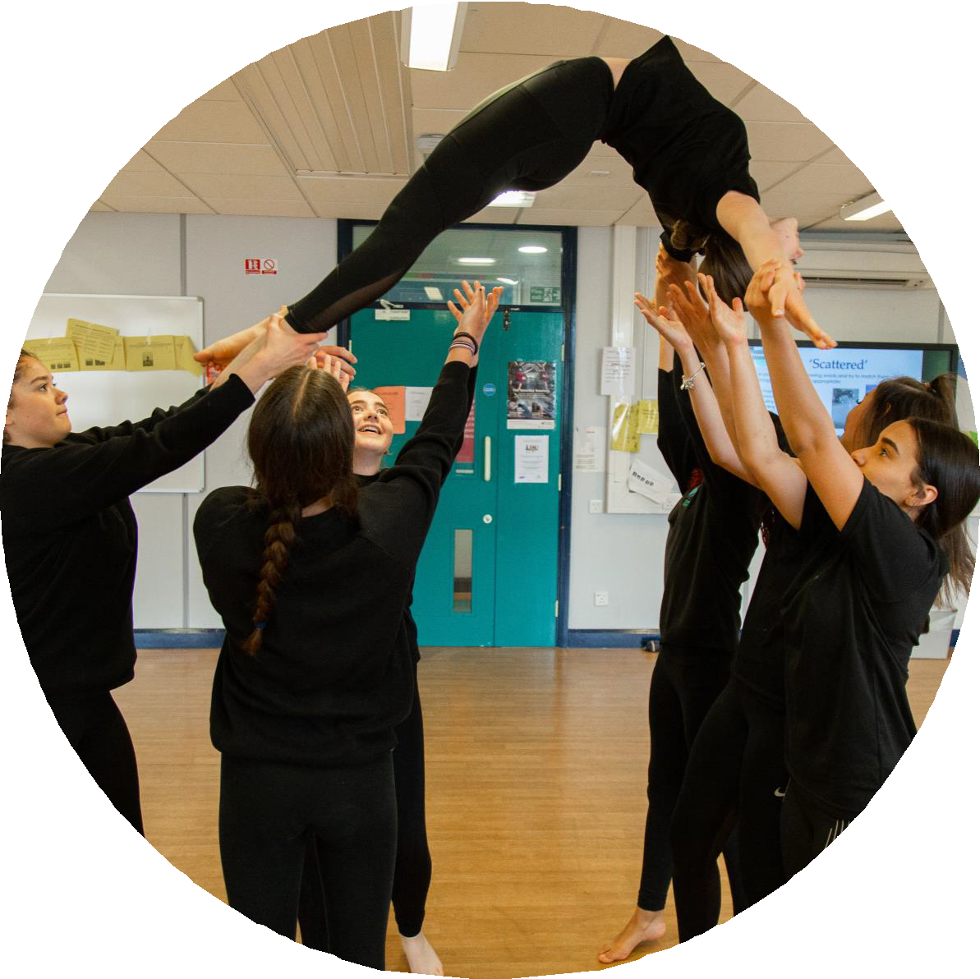World-leading teacher CPD delivered by Goldsmiths, University of London
* Inspiring nearly two million pupils across 4,000 schools every year
* A flexible framework that fits around school planning cycles with only two documents to submit.

**Photo © Canteencreate / LIPA Primary and High School**

# Transforming schools

**Artsmark transforms whole schools and their local communities through creativity**

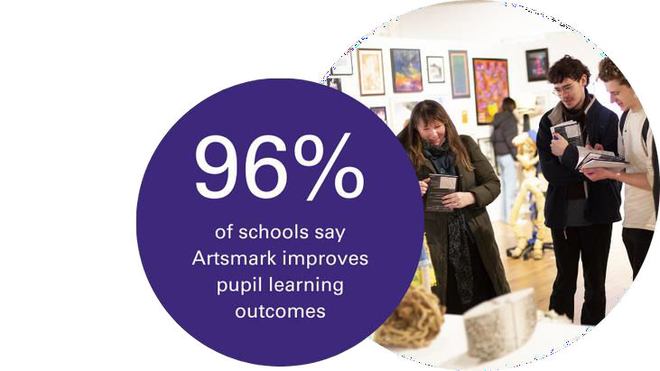

# Why is cultural education important?

The **Cultural Learning Alliance's 2017** [***Imagine Nation***](https://www.culturallearningalliance.org.uk/about-us/imaginenation-the-value-of-cultural-learning/)**report** on the impact of cultural education showed:

* participation in structured arts activities can increase **cognitive abilities by 17%**
* learning through arts and culture can **improve attainment** in Maths and English
* students from low-income families who take part in arts activities at school are **three times more likely to get a degree**

The Centre for Social Justice’s 2023 [***Two Nations***](https://www.centreforsocialjustice.org.uk/wp-content/uploads/2024/01/CSJ-Persistent_and_Severe_Absence.pdf)[***report***](https://www.centreforsocialjustice.org.uk/wp-content/uploads/2024/01/CSJ-Persistent_and_Severe_Absence.pdf)argues that improved access to extra-curricular

activities (including arts enrichment) could be part of the solution to

the current attendance crisis. **Photo © Mark Savage / Havelock Academy**

# How Artsmark can help

Artsmark is proven to use creative and cultural education to:

* support pupil outcomes, wellbeing and attendance
* 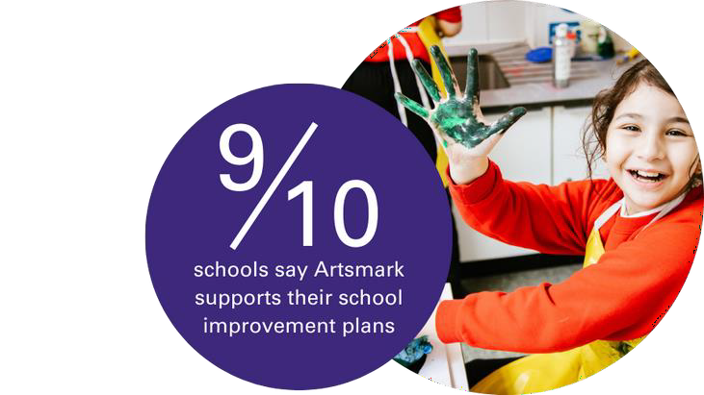improve teacher recruitment, retention and confidence
* significantly contribute to whole school improvement

**Photo © Xavier Fiddes / Northway Primary School**

# World-leading CPD

Artsmark training and support is delivered by [**Goldsmiths, University**](https://www.artsmark.org.uk/support-resources/goldsmiths-training-and-support)[**of London**](https://www.artsmark.org.uk/support-resources/goldsmiths-training-and-support). Goldsmiths is a research and teaching university with a national and international reputation as a hub for creativity, arts and culture.

Your staff will feel empowered to become **agents of change,** building their confidence in **using action research** whilst developing

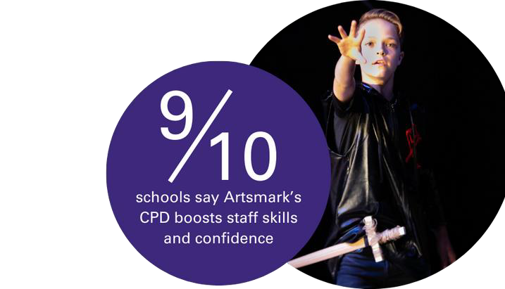

## critical analysis and reflection skills.

**“I thought the training was really empowering. I left excited to compile the information needed to complete our Statement of Impact to show what we have achieved as a school.”**

**Photo © Rob Freeman**

# Artsmark and Ofsted

* + Artsmark can significantly contribute to meeting Ofsted’s requirements for Quality of Education by using the Artsmark framework to maintain a broad and ambitious curriculum that connects learning across all subjects, as well as working towards Gatsby benchmark 5.
  + Artsmark equips pupils with the cultural capital they need to succeed in life and nurture their imagination and creativity through a high- quality arts and cultural education.
  + Artsmark has the potential to clearly demonstrate how you support personal development and provides evidence to Ofsted on how you meet its spiritual, moral, social and cultural requirements.
  + Artsmark considers the Ofsted framework in the resources it develops for schools, supporting leaders to understand how Artsmark can support the development of a broad and balanced curriculum.

# What Artsmark schools report

* + 96% say Artsmark’s improved their **pupils’ learning outcomes**
  + 98% say Artsmark broadens and **enriches their curriculum**
  + 96% say Artsmark’s supported **school improvement plans**

**"We have seen an increase in whole**

**school attendance over the course of our Artsmark journey. There has been a subsequent improvement in wellbeing and happiness which translates into**

**higher levels of attendance."**

Springfield Junior School, Artsmark Gold

# A long-term investment

Artsmark costs just £500 for the entire two-year Artsmark journey, plus a further two years’ accreditation from the Arts Council. If you have fewer than 100 pupils, the cost is just £250.

This investment provides access to a wealth of CPD benefits including:

* + Artsmark **development training** for two members of staff delivered by Goldsmiths, plus ongoing support
  + a **clear framework** to plan, develop and embed arts, culture and creativity across the curriculum

# Our work with the NGA

The Arts Council has a strong partnership with the National Governance Association and has developed an e-learning module for governors and trustees about the value and impact of arts and cultural education, and how to embed across the organisation.

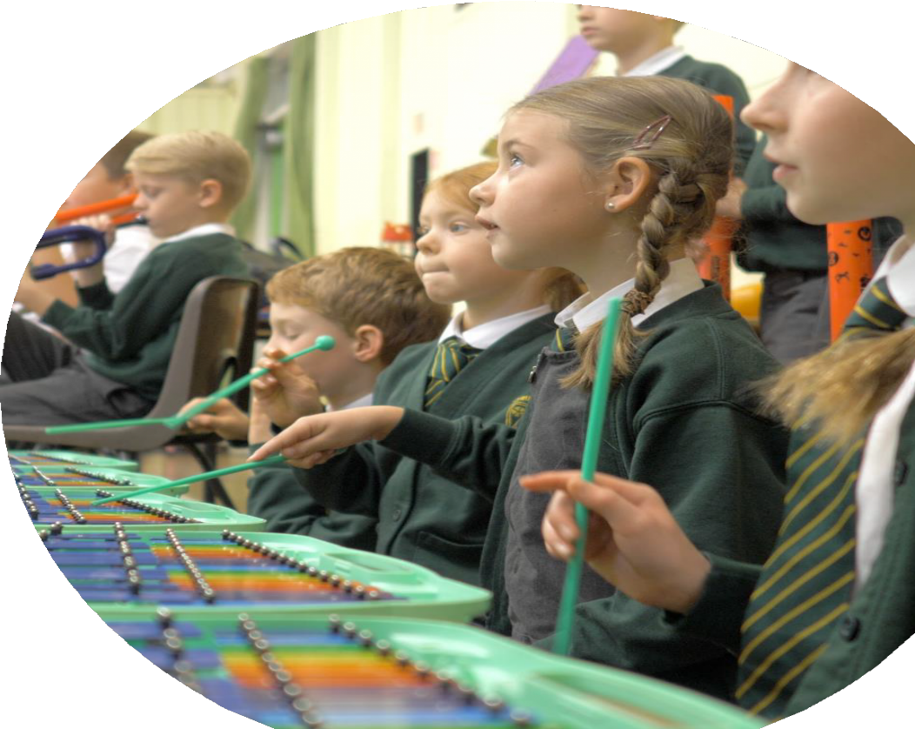The module, available to NGA

members, enables governors and trustees to develop their understanding of what arts and cultural education means and how it can be used for school improvement and enhancing the school curriculum.

Artsmark encourages governors and trustees to [**take the module**](https://www.nga.org.uk/training/directory/arts-culture-creativity-improving-school-trust-curriculum/)and learn more about the value of cultural education.

**Photo © Jack-All Productions / Strike Lane Primary School**

# Ready to get started?

It’s easy to get started. Complete a short online form and we’ll be in touch with your next steps.

[**artsmark.org.uk/register**](http://www.artsmark.org.uk/)

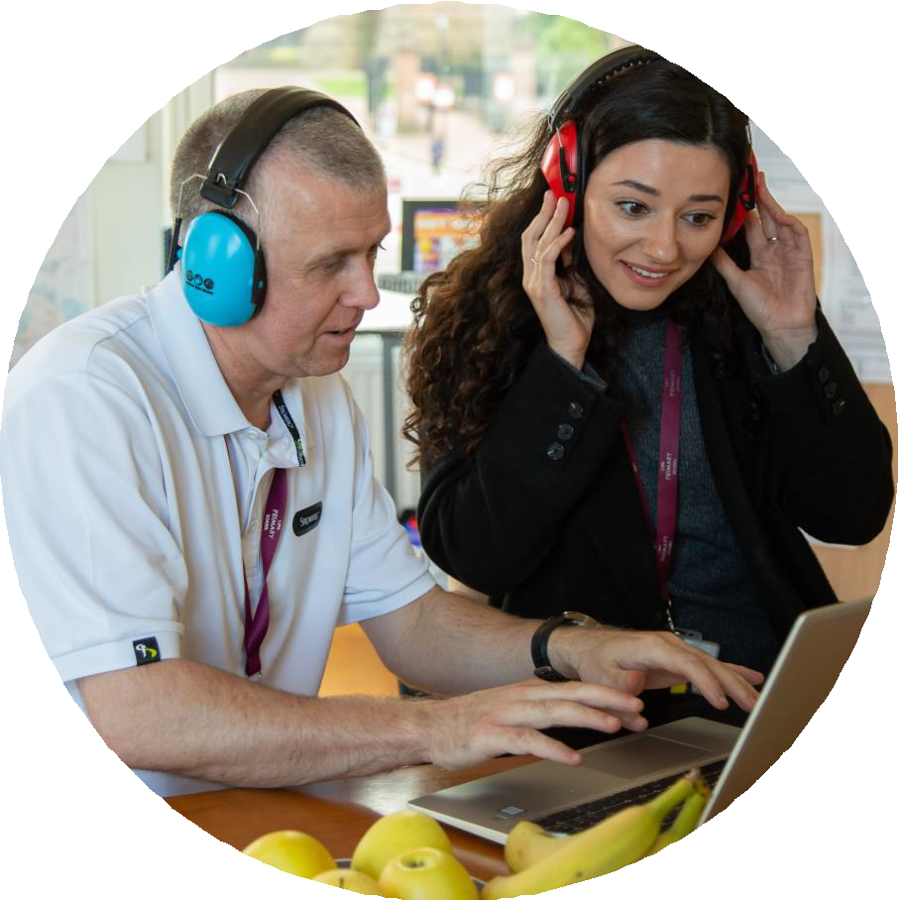

**"Our Artsmark journey has been a**

**great success. Staff are really seeing the difference that learning through being creative can make to pupil**

**understanding and wellbeing."**

Highfield Littleport Academy,

Artsmark Silver

**Photo © Callum Mcmorran / LIPA Primary and High School**



**Useful links**

**Artsmark web pages:** [www.artsmark.org.uk](http://www.artsmark.org.uk/) [www.artsmark.org.uk/process](http://www.artsmark.org.uk/process) [www.artsmark.org.uk/register](http://www.artsmark.org.uk/register) [www.artsmark.org.uk/costs](http://www.artsmark.org.uk/costs) [www.artsmark.org.uk/training](http://www.artsmark.org.uk/training)

**NGA e-learning module:** [https://www.nga.org.uk/training/directory/arts-](https://www.nga.org.uk/training/directory/arts-culture-creativity-improving-school-trust-curriculum/) [culture-creativity-improving-school-trust-](https://www.nga.org.uk/training/directory/arts-culture-creativity-improving-school-trust-curriculum/) [curriculum/](https://www.nga.org.uk/training/directory/arts-culture-creativity-improving-school-trust-curriculum/)

## Cultural Learning Alliance reports:

[https://www.culturallearningalliance.org.uk](https://www.culturallearningalliance.org.uk/)

**Photo © Matthew Tiller**